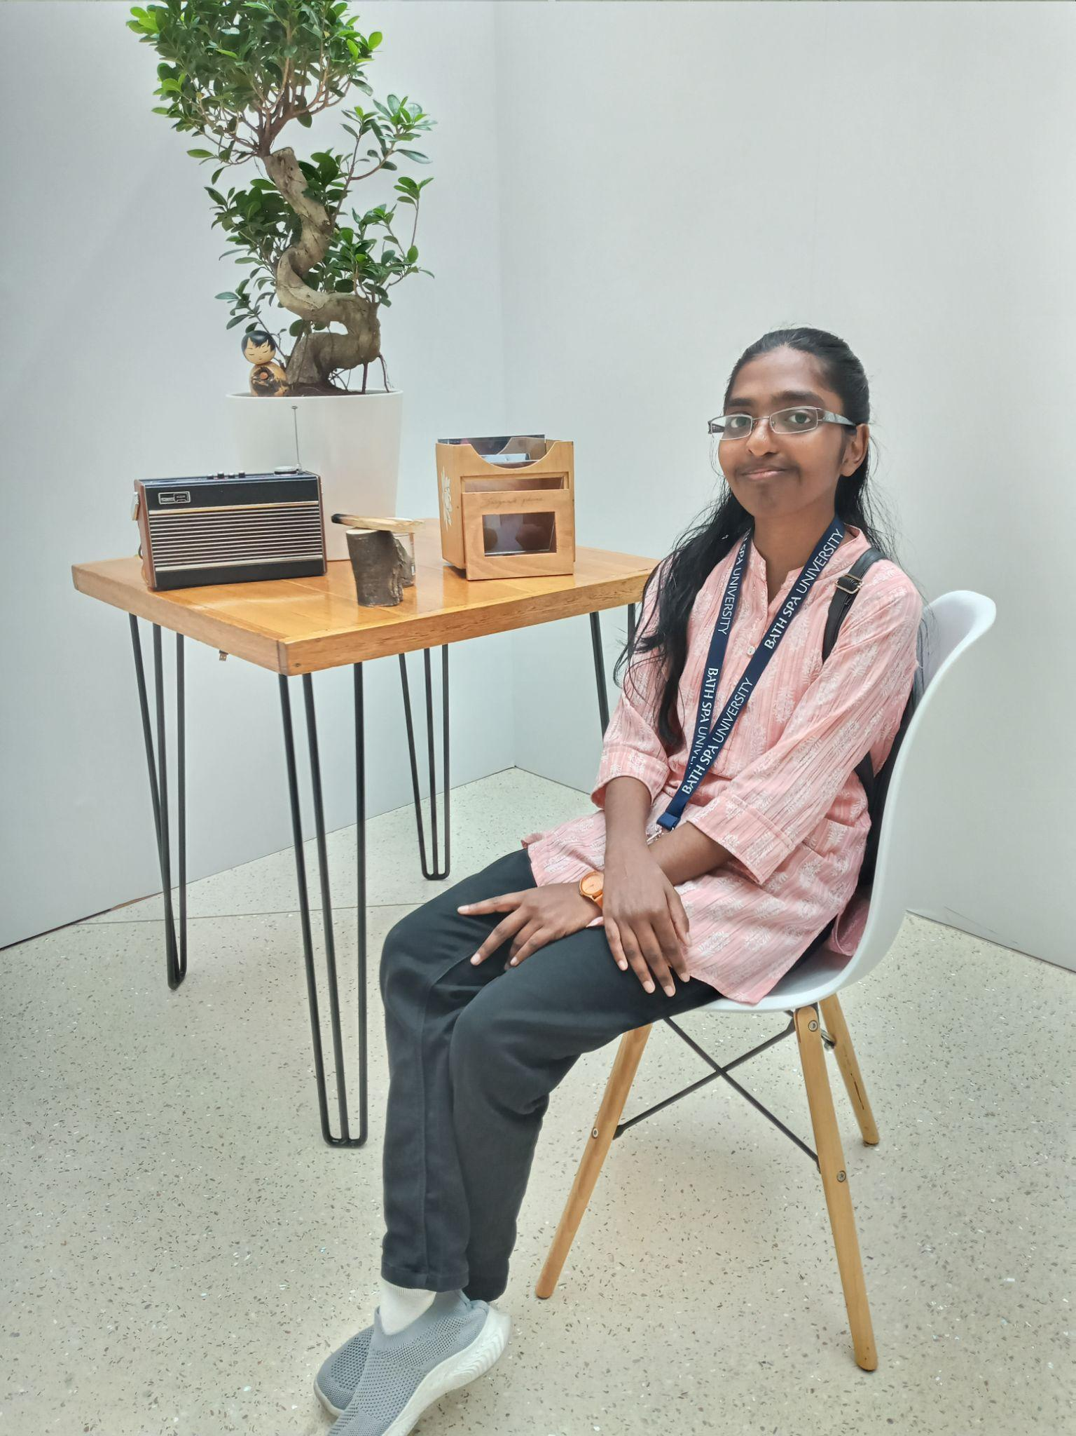
Education:

Angel Sara Mathew
Fresher

- Contact

- Email:angelsaramathew2004@gmail.com
- Phone:+971581981921

- Language

- English
- Malayalam

- Skills

- Figma Design
- Canva Design
- Html and Css
- Data Visualization

- Hobbies

- Writing
- Cooking
- Make story video
- Crafting
- Design

- 10th passed in 2021 at The Emirates National School, Sharjah
- 12th passed in 2023 at The Emirates National School, Sharjah
- Currently studying the final year of BSc Creative Computing at Bath Spa University, Ras Al Khaimah.
Programming Language:
- Python,
- SQL,
- JavaScript,
- HTML,
- CSS.
- Kotlin
Development tools:
- Figma,
- Canva,
- Tkinter,
- Visual Studio,
- GitHub,
- Android Studio
- Flourish
- Dialogflow
- Vite react
Experience in:
- We created a vending machine using Python and learned about ideation and design using Figma and Canva. I created a website using HTML, CSS, and JavaScript. Developed apps in Tkinter and Android Studio and designed apps in Figma. Created a Chatbot using Dialogflow and created charts in Flourish on E-commerce.

- Completed a research paper and debated the topic: The role of AI in enhancing translation and breaking language barriers. Created time-lapse videos. Developed story game “Marvellous life of a parrot” in Twine and Bitsy game.
YouTube link:
https://www.youtube.com/@angelsaramathew2926. Here, you can explore the projects I've completed.

Certificates:
